**Leader Overview**

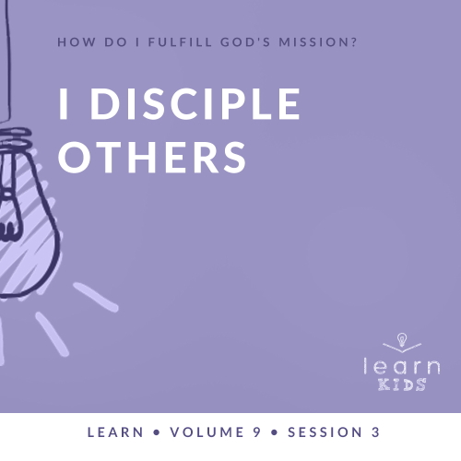

**Volume Overview**

**How do I fulfill God’s mission?**

*Christianity is so much more than only another religion. It’s not just another collection of rules and regulations. It’s a real relationship with Jesus Christ. When we give our heart to Jesus, He becomes our Savior and our Lord. Life is not only full of responsibilities, bills, and work, but it can also be full of eternal purpose.*

*As we grow closer to God, He begins to reveal His true purpose and plans for our life. We begin to discover the personal mission and assignment He has designed for each of us. While we may have different gifts, talents, and abilities, each of us is called to the same mission of helping to transform the world with God’s love and power. God calls us to personally share our faith, to help lead others toward a deeper walk with Christ, and to help others fulfill their individual mission. As we lean into God and allow Him to make a difference in our life, He will in turn use us to make a difference in the life of others.*

**Session Overview**

**I Disciple Others**

*Everyone can grow by learning from the experiences of others. Timothy received a lot of instruction from Paul that helped him to be a better Christian and leader. Timothy used that instruction to go on to help others too. As Christians we should be eager to learn from others, but God also wants us to lead others by setting an example and sharing encouragement.*

**Bible Lesson**

Paul Disciples Timothy

[Acts 16:1–5](https://ref.ly/logosref/Bible.Ac16.1-5); [2 Timothy 1:3–6](https://ref.ly/logosref/Bible.2Ti1.3-6)

**Faith Fact**

I will lead others.

**Faith Verse**

[Matthew 28:19](https://ref.ly/logosref/Bible.Mt28.19)

“Therefore, go and make disciples of all the nations, baptizing them in the name of the Father and the Son and the Holy Spirit.”

**Preparing for the Session**

**Leader Preparation Time: 20–25 Minutes**

|  |
| --- |
| ***You Will Need***  ***Large Group***   * *Bible* * *Worship songs (Song suggestions: “Tell His Story” lyric video by Yancy; “Real Love” lyric video by Hillsong Young & Free; “For the One” by Brian and Jenn Johnson; “Build My Life” by Passion)* * *For groups not using a phone or tablet only, add:*   *• Projector or TV*  *• Laptop*  *•* ***Faith Fact Slide***  *•* ***Faith Verse Video*** *or* ***Slide***  *•* ***Bible Lesson Video***  *•* ***Teaching Point Slides 1–3***  ***Small Group***   * *Various obstacles (chairs, boxes, trash cans, something to duck under/climb over, etc.)* * *Blindfolds* * *Tape* * *Bibles for kids in your group to share* * *Foam ball or other soft ball* * ***Small Group Activity Page****, one per kid* * ***Small Group Activity Page Answer Page****, one per leader* * *Pencils, one per kid*   *To access session content and videos from a computer, visit:* [*BibleEngagementProject.com/downloads*](https://bibleengagementproject.com/downloads) |
| ***Getting Ready***  ***Large Group***   * *Download videos and slides if needed.* * *Select worship song(s) and have them ready to play.* * *Read the Bible Lesson Scripture to prepare for Teaching Time.*   ***Small Group***   * *Set up an obstacle course using various materials available to you. Make a tape line that acts as a pathway for kids to follow.* * *Prepare blindfolds to be used by multiple kids.* * *Print copies of the* ***Small Group Activity Page****, one per kid, and a* ***Small Group Activity Page Answer Page****, one per leader.*   *First time leading* Learn *for Kids? Check out the* [*Facilitator Guide*](https://0b769b0ed3569ef9d18b-f88d8272f61086866d50d048b43ef630.ssl.cf2.rackcdn.com/sites/biblengagementproject/Listen_Facilitator_Guide.pdf)*.* |

**Large Group**

**30 Minutes**

*See what’s needed at the beginning of the session.*

**Introduction**

Welcome, everyone! We’re learning all about how we can fulfill God’s mission to help people know Him better and get closer to Him. One way that happens is by leading other people. Raise your hand if an adult has ever taught you how to do something. *(Group response)* What did they teach you? (*Allow responses.*)

I’m so glad you and I have people around us who can teach us what they know—whether it’s riding bikes, tying shoelaces, or doing homework problems. Today, we’re going to see how Paul showed someone else how to follow Jesus.

**Faith Fact**

Are you ready for today’s super important phrase to remember? *(Group response)* Our Faith Fact is: **I will lead others**.

• *Show the* ***Faith Fact Slide.***

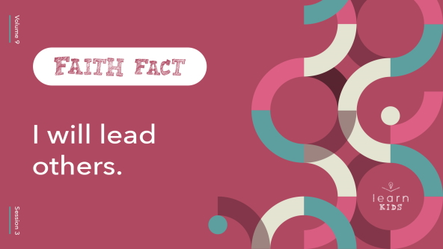

Let’s say the Faith Fact together a couple of times to get it in our mind. Stand up and shout it like a medieval knight. **I will lead others.** One more time. **I will lead others.** Great job!

**Game**

**Rock, Paper, Scissors Snake**

Let’s play a game! Who’s played Rock, Paper, Scissors before? *(Group response)* Well, today’s game is called Rock, Paper, Scissors Snake! Here’s how it works. Everyone will get up from their seat and pick a partner. When I say, “Go,” you’ll face off with a round of Rock, Paper, Scissors.

• *Review the actions and rules if kids are unfamiliar with the game.*

If you win the round, you become the leader. The person you just played will line up behind you and follow you around for the rest of the game. Pair up with someone else who won and play Rock, Paper, Scissors again. Whoever loses that round will get in line behind the winner, forming a longer snake behind them! We’ll play until there is only one winner left with a snake of everyone else behind them.

• *Play the game as time allows.*

That was an awesome game! You did a great job following your leader. *(Winner)*, you did a terrific job leading everyone, too.

It was pretty simple to lead and follow your friends in the game. Sometimes, we don’t need to be led when we do simple things. But other times we need help. We need someone to teach us the right way to do something. That’s a perfect description of today’s Bible story about Paul and Timothy. We’ll talk more about that soon, but first it’s time to worship God!

**Worship**

I’m so thankful God puts people in our life to love us and lead us. We can thank Him for that when we worship. Who’s ready to worship God today? *(Group response)* One way to worship God is by singing, so let’s do that together right now!

• *Lead the kids in singing one or two praise songs. See suggestions at the beginning of the session.*

• *Optional: Choose kids to lead the rest of the group.*

**Bible Lesson**

What an incredible time of worshipping God together! Now it’s time to learn from God’s Word. We’re going to find out how Paul helped to fulfill God’s mission by leading someone else. Let’s check it out! As we begin, let’s pray.

**Prayer**

|  |
| --- |
| *Dear God, thank You for Your Word. Please help us discover how we can lead others to You today. Amen.* |

**Video Intro**

Just before we get into the Bible story, let’s watch this video.

• *Play* ***Bible Lesson Video****.*

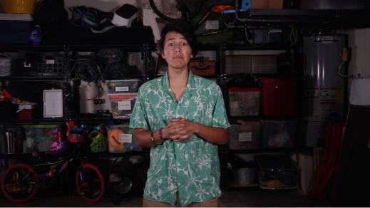

**Bible Story**

**Paul Disciples Timothy**

That video really made me want to find out more about our Bible story! Remember when I asked you earlier if someone older had ever helped you learn something new? Now imagine you got the chance to teach another person how to do the thing you just figured out. Wouldn’t that be awesome? The Bible shows us how to lead others in a way that honors God. So grab your Bible or pull up a Bible app on your device and find [Acts 16:1–5](https://ref.ly/logosref/Bible.Ac16.1-5).

• *Read* [*Acts 16:1–5*](https://ref.ly/logosref/Bible.Ac16.1-5) *and* [*2 Timothy 1:3–6*](https://ref.ly/logosref/Bible.2Ti1.3-6) *aloud to the group.*

• *In order to keep Large Group time moving along, we don’t recommend having the kids read.*

• *Optional: Remind the kids to mark this place with their Bible Bookmark, so they can read it on their own at home.*

**Teaching Time**

How awesome to help someone grow to have a strong, courageous faith in God that inspires others! That’s what Paul did for Timothy, and that’s what I get to do when I’m with you. And you know what? God wants *you* to help people learn about Him and grow closer to Him too! It takes time, but it’s worth it. That’s why our Faith Fact is so important. **I will lead others**. Say that with me as loudly as you can. **I will lead others**.

Let’s talk about three big things you need to know about leading others.

**1. Everyone needs leaders to help them grow.**

• *Show the* ***Teaching Point 1 Slide.***

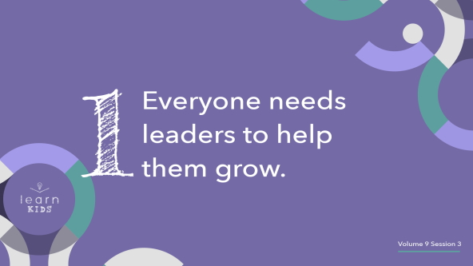

Let’s talk about a word you may not have heard before except in our Faith Verse: *disciple*. A *disciple* is someone who follows a person who is teaching them. The Bible tells us Jesus had twelve very close followers or disciples. They traveled with Jesus and learned about God from the things Jesus said and did. The disciples grew a lot in their faith because Jesus was leading them.

Our Bible passages told us how Timothy began to work with Paul. Timothy was Paul’s disciple and helped him on his travels with other believers like Silas, Luke, and Barnabas. Timothy had a lot to learn about following Jesus, sharing the gospel, and life in general. But Paul was older and could give him good advice. Paul led Timothy as he grew in his relationship with God. Paul helped Timothy get ready for what God was telling him to do.

Have you ever seen farmers or a gardener planting seeds in the ground? *(Group response)* Anyone can scatter seeds on the dirt and hope healthy crops grow. But there’s more to it than that! Good farmers dig up the soil to get it ready. They put fertilizer on the field. They plant the seeds carefully. They make sure the seeds have plenty of water. They keep away birds and bugs and weeds. Seeds that have been cared for like this are much more likely to grow into big crops!

It’s the same with people. Everyone grows better with leaders helping. We are like the seeds, and our leaders are like the farmers. Your leaders could be your parents, grandparents, other family members, coaches, teachers, pastors, or church leaders. They can help you grow into the person God wants you to be.

**2. God wants us to set an example for others.**

• *Show the* ***Teaching Point 2 Slide.***

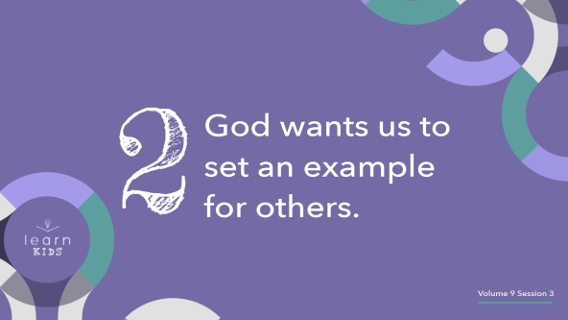

Here’s the awesome thing. When Timothy started growing and helping Paul share the gospel, Timothy became a leader too! Timothy showed other people what it looked like to serve God. If people did what Timothy was doing, they’d be able to grow too.

When we watch others following and serving God, we start to see that it can be done. Maybe obeying God and doing the right thing is easier than we thought. Maybe telling people about Jesus isn’t scary after all. That’s why God gives us leaders to follow.

Think of someone who is a good example for you. Maybe they show you how to live for God. Maybe they have a special talent you want to learn. Maybe they are kind and loving to you and your family. Anyone who inspires you to grow in your faith in God is a good example for you.

You may not know it, but you are an example to someone else too. Think about that! Other people are watching you and will follow what you do. Let’s make sure we’re being good examples, not bad ones. Think about how you can use your actions to inspire and lead other people to honor God.

**3. God wants us to help others grow in their faith.**

• *Show the* ***Teaching Point 3 Slide.***

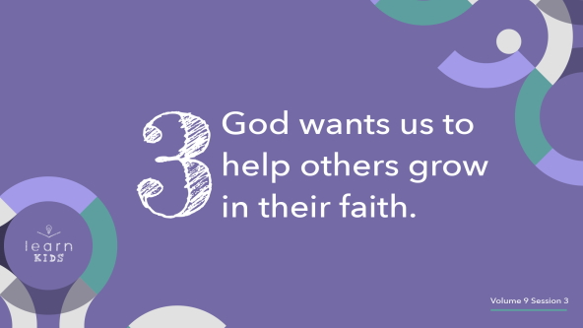

Paul was a great leader for Timothy. But Paul didn’t stop there. He told Timothy to go and teach even more people. So Timothy kept growing and leading even when Paul wasn’t with him anymore.

God wants us to lead others and help them grow while we’re following our own leaders. This can be a little hard to understand. How could I lead someone else if I’m not finished growing yet? Here’s a pro tip: You’ll never finish growing to be more like Jesus. Your leaders are still growing. I’m still growing in my faith. And you’re still growing too! There are always new things to learn and new ways to grow.

Remember the farmers and gardeners we talked about earlier? If they want to grow even more crops, they could get help from farming experts. Maybe those experts know more about plowing, planting, or protecting the seeds. With extra help, our farmers could double their crops!

God wants us to keep growing while helping others grow too. Did you know Paul told Timothy not to let anyone think he was too young to be a leader? *(Group response)* Maybe you feel too young to lead others, but you aren’t! If you ask God to help you, He will. Soon you’ll be showing other people how to follow Jesus. God will make it happen at the right time. This is how we fulfill God’s mission.

**Prayer and Response**

*Consider playing a worship song softly in the background while kids pray.*

Sometimes it can be scary to think about leading someone else in their faith. Maybe we think we don’t know enough or aren’t good enough. But God wants to use each one of you. Let’s take some time to ask God who we can lead. I believe God can answer these questions for you: “Who should I lead?” and “Who should I be led by?”

• *Take a few quiet moments for the kids to think and listen.*

**Prayer**

• *Optional: Have the kids repeat phrases of the prayer after you.*

|  |
| --- |
| Dear God, thank You for leading me every day. Please help me find the people You want me to follow. And show me how I can lead others closer to You too. Amen. |

**Faith Verse**

Our Faith Verse reminds us that God wants us to lead others. Let’s do the actions together as we say it.

• *Play* ***Faith Verse Video****.*

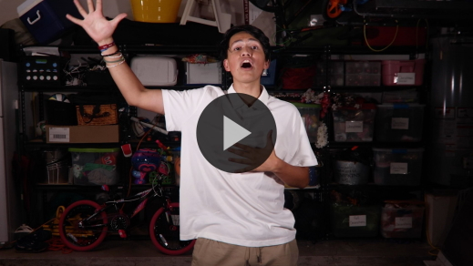

[Matthew 28:19](https://ref.ly/logosref/Bible.Mt28.19) (NLT)

“Therefore, go and make disciples of all the nations, baptizing them in the name of the Father and the Son and the Holy Spirit.”

Do you remember the way we make disciples and lead others to God? We tell them the good news of God’s love!

**Faith Fact**

Before we go to our small groups, let’s say our Faith Fact one more time.

• *Show the* ***Faith Fact Slide****.*



Say it with me. **I will lead others.** God will help you grow so you can lead other people to Him. God will give you everything you need to fulfill His mission!

• *Dismiss kids to Small Group time or to go home if your group time ends here.*

**Small Group**

**30 Minutes**

*This section can be done in conjunction with the large group or on its own if you do small groups with your kids. During Small Group time, the goal is to connect the kids with the Word of God and to each other. All activities are led by the small group leader.*

**Group Connection**

**Obstacle Course**

|  |
| --- |
| ***You Will Need***   * *Various obstacles (chairs, boxes, trash cans, something to duck under/climb over, etc.)* * *Blindfolds* * *Tape*   ***Getting Ready***   * *Set up an obstacle course using various materials available to you. Make a tape line that acts as a pathway for kids to follow.* * *Prepare blindfolds to be used by multiple kids.* |

When we’re trying something new, it can sometimes feel like we’re blindfolded. Where are we going? What should we do next? But when we have leaders in our life, they help us know how to make it through.

Let’s test our listening and following skills. I’ll pick someone to put on a blindfold and go through the obstacle course. Everyone else will call out directions to help them finish the course. When you’re blindfolded, do your best to listen to your friends!

• *Repeat as time allows with each kid.*

That game was fun, wasn’t it? When others are leading us, we have to pay close attention to what they say. And when we lead others, we have to give careful instructions. Learning new things can be hard. But God can help us lead others closer to Him every day!

**Learn about It**

|  |
| --- |
| ***You Will Need***   * + *Bibles for kids in your group to share*   *No prep is needed.* |

**Scripture Search:** [1 Timothy 4:12](https://ref.ly/logosref/Bible.1Ti4.12); [2 Timothy 3:10–11](https://ref.ly/logosref/Bible.2Ti3.10-11); [1 Corinthians 11:1](https://ref.ly/logosref/Bible.1Co11.1); [2 Timothy 1:6–7](https://ref.ly/logosref/Bible.2Ti1.6-7)

Let’s dig deeper into God’s Word and see what else He has to say to us. The verses we’ll read are words that Paul wrote to Timothy. As we find and read each of them, let’s ask ourself this question: What does this Scripture mean for our life today?

• *Give each kid a Bible and search for one or more of the Scriptures as a group together (as time allows). When everyone has found the Scripture, have one of the kids read it. Then answer the question about it.*

• *Pair kids who need additional help with older kids or start simple and look up the session’s Bible story Scripture:* [*Acts 16:1–5*](https://ref.ly/logosref/Bible.Ac16.1-5)*;* [*2 Timothy 1:3–6*](https://ref.ly/logosref/Bible.2Ti1.3-6)*. Kids will get better at finding Scriptures the more they practice.*

• *Optional: Make this a competition to see who can find the Scripture first.*

**Bible Reading Tip**

The Bible can be pretty hard to understand sometimes. There are complicated stories, long lists of names, and different kinds of writing. It’s normal to feel a little confused when you start reading the Bible. Remember, the leaders in your life will help if you have questions or don’t know where to begin. You can also ask the Holy Spirit to show you what God’s Word means. He is always ready to help!

**Challenge**

I have two challenges for you to pick from today. First, if you know a lot about the Bible, look for a way to lead someone else. Maybe you can tell them about your favorite story or character. Maybe you can help them find a Bible or Bible app. Or maybe you can explain how reading the Bible has helped you grow closer to God.

Here’s the second challenge. If you don’t know a lot about the Bible yet, be brave and ask a friend or leader to help you get started. God wants you to grow. He will show you the right person to lead you closer to Him.

**Faith Fact**

God’s Word is powerful. When we read it and follow what it says, we get closer to God and learn to lead others. That reminds me of our Faith Fact: **I will lead others.** Say it with me in a strong voice. **I will lead others.**

**Group Discussion**

*Feel free to use all or just a few questions as a jumping-off place for good discussion. Questions marked with * are designed for more conversation. Adjust the questions based on the age or maturity of your group. Typically, older kids will be able to dive a little deeper than younger ones.*

**Questions**

• *If small group activities are not immediately following large group time, you may want to read the Bible story passage before this discussion.*

* What’s something you enjoy doing that someone else taught you to do?

* Have you ever taught a new skill to someone else? What was it?

What was the name of the man Paul was leading in our Bible story?

What stuck out to you most about this story?

Who is one of your leaders as you grow closer to God?

How can you be a good example to others?

Who can you help lead closer to God?

* Is it easy to follow someone else’s advice? Why or why not?

* How would your life be different if you saw yourself as a leader?

**Prayer Requests**

*Finish group discussion by sharing prayer requests and praise reports. Keep track of your small group’s prayer requests and review them each time you meet.*

**Prayer**

*Have kids pray for each other’s prayer requests.*

**Faith Verse Review**

|  |
| --- |
| ***You Will Need***   * + *Foam ball or other soft ball*   *No prep is needed for this activity.* |

Our Faith Verse is [Matthew 28:19](https://ref.ly/logosref/Bible.Mt28.19). Do you remember what else this verse is called? *(Allow responses.)* It’s the Great Commission! Jesus told His followers about God’s plan for all of us to share the good news of His love. Let’s say it together now.

• *Show* ***Faith Verse Video****.*



[Matthew 28:19](https://ref.ly/logosref/Bible.Mt28.19) (NLT)

“Therefore, go and make disciples of all the nations, baptizing them in the name of the Father and the Son and the Holy Spirit.”

God wants to use you to lead others closer to Him. You do that when you share the truth about Jesus and all He’s done! Let’s say our Faith Verse a couple of more times. Try to memorize it as best you can, because you’ll need to know it for our game.

• *Say the verse as a group a couple of times.*

**Faith Verse Fun**

**Toss Across**

Let’s play a game called Toss Across! Here’s how it works. Whoever has the ball first will say the first word of the verse. Then they’ll toss the ball across the circle to someone else. That person will say the next word. We’ll keep tossing the ball around until we say the whole verse!

• *Have kids stand in a circle for the game.*

• *Repeat the process until the whole verse is recited. Consider racing for a time record.*

Great job! This verse is great to keep in our mind and heart. It reminds us to stay focused on God’s mission.

**Activity Page**

|  |
| --- |
| ***You Will Need***   * + ***Small Group Activity Page****, one per kid*   + ***Small Group Activity Page Answer Page****, one per leader*   + *Pencils, one per kid*   ***Getting Ready***   * *Print copies of the* ***Small Group Activity Page****, one per kid, and one copy of the* ***Small Group Activity Page Answer Page*** *for the leader.* |

Today’s Activity Page is a word find puzzle. We’re going to find words about leading and following! Let’s see how quickly you can find all the words.

• *Give kids a copy of the* ***Small Group Activity Page*** *and a pencil. Assist younger kids as needed.*

**Dismissal**

Remember, God wants to use you and me to lead others closer to Him. When we follow the Holy Spirit and listen to the other leaders in our life, we will fulfill God’s mission. We will lead other people to follow Jesus. Let’s close in prayer.

**Prayer**

|  |
| --- |
| *Dear God, please help us find leaders who will help us grow in our relationship with You. Show us how to lead others to follow You as well. Amen.* |

**Faith Fact Recap**

• *Show the* ***Faith Fact Slide****.*



Let’s say our Faith Fact together one more time. Make sure you remember this one important truth from our time today. **I will lead others.** I’m so glad you came. And I’m already excited about seeing you next time!

• *Send home the* ***Small Group*** ***Activity Page.***

• *Remind parents that there are* ***Family Devotions*** *available on the app to do with their kid.*

• *Tell everyone the date and time for the next session.*